Often, there is confusion between when to choose SNS or SQS . A simple decision making process for this .
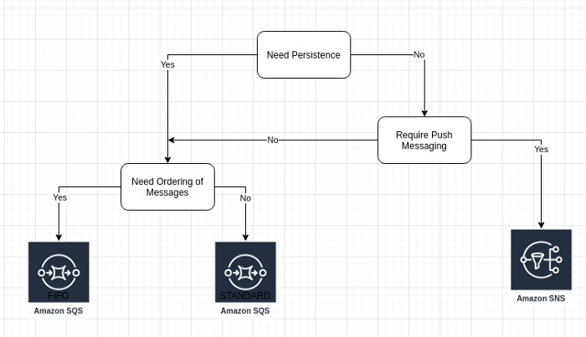

Let’s get started
Prerequisites:
- An AWS Account

Step 1:
Locate SQS on AWS console.
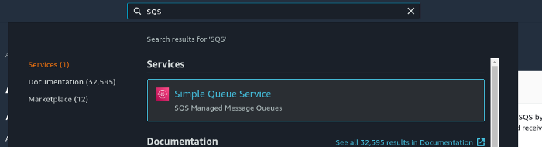

Step 2:
Click on Create Queue
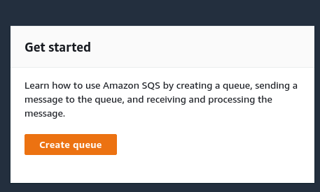

Step 3:
Configure the queue . Select “Standard” queue for this tutorial. You can also try “FIFO”queue later on to experience the changes in message handling influenced by this selection.
Set the name as “MyStandardSQSQueue”
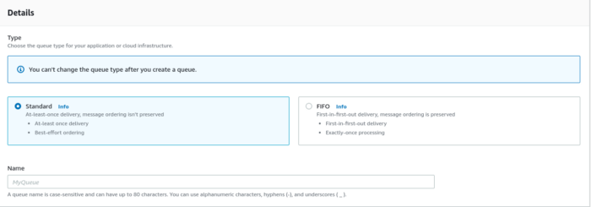
Additional configuration settings . Pay attention to the message size , retention period ,visibility timeout . These are going to be useful in later steps.
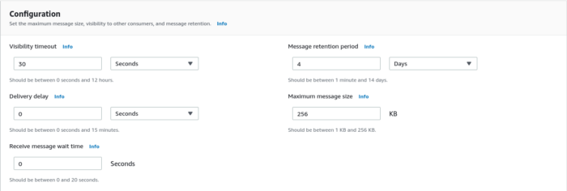
Scroll down further and for now setup the Dead-letter queue to be disabled. We will come back later to this setting. Hit “Create queue”
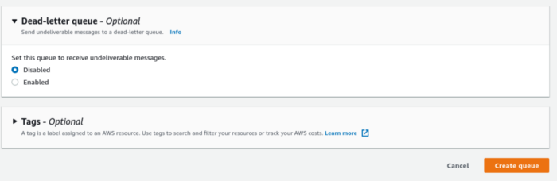
Now you should see the queue ready.


Step 4:
Now repeat Steps 1 through 3 to create another queue called “MyStandardSQS_DLQ”
Link the Dead-Letter queue created above to the original queue “MyStandardSQSQueue” by editing the queue with the edit option

Select the Dead-Letter queue ( your queue shows up in the option ).
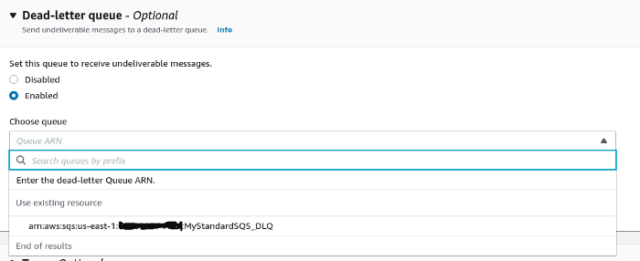
Also set the Max-Receives property while you are editing the Dead-Letter queue property for your queue .
Why is this important ?
Because this determines when a message needs to be moved to the Dead-Letter queue.After 10 attempts of a message landing in your base queue , it will be automatically moved to the Dead-Letter queue


Step 5:
A quick verification of all the settings.
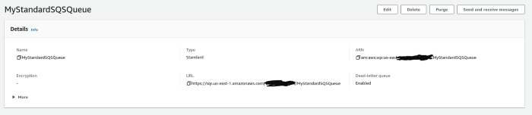

Step 6:
Let’s now take a look at the integrations that you can enable for your SQS queue which lies in the SQS
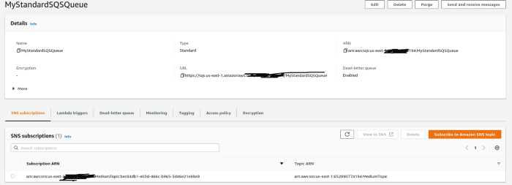
I have an SNS subscription integrated to my SQS as a “Publisher”. Try to remember the role of a publisher here.
This step is not mandatory and you can simply publish message to the queue from the console ( which we will see in the subsequent steps ). But it will be a good idea for you to understand how messages are being published by an integration such as SNS . To know more about SNS , please read my article here.
Often, SNS and SQS are coupled in architecture design . However it is not necessary to couple SNS and SQS . Both of these services can function independently without each other.

Step 7:
Let’s publish a message from console.Hit the “Send and Receive Messages” button
Add message details . Observe the Message Attributes . We can access these when the message is received in the queue.
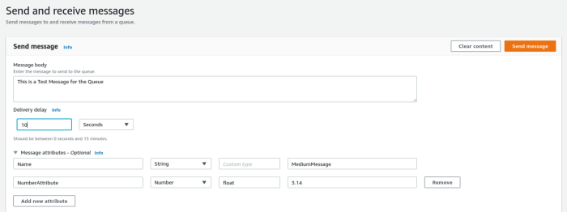
Hit “Send Message” to get the confirmation.
Now, hit the View Details to see the message details. Take note of the ID ( unique ID for the message you published to the queue )
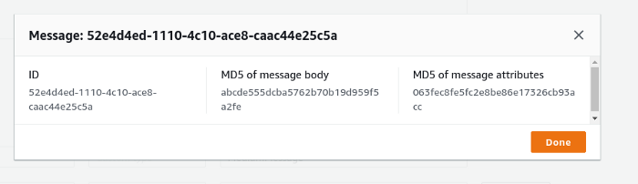

Step 8:
If you scroll down on the same page immediately you’ll see the following panel which does not shows the message that you just sent . Why ?. Remember the visibility parameter that we had set in Step 3 at 30 seconds. So any message sent to this queue will be visible in the queue only after 30 seconds. This timeout enables subscribers to avoid duplicate processing of the same message.
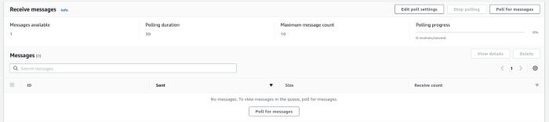

Step 9:
Polling for messages. You should see the message you sent a while ago.
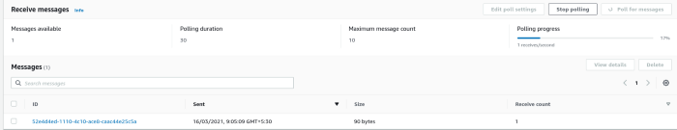

Step 10:
Now click on the message to see more details . Observe the metadata
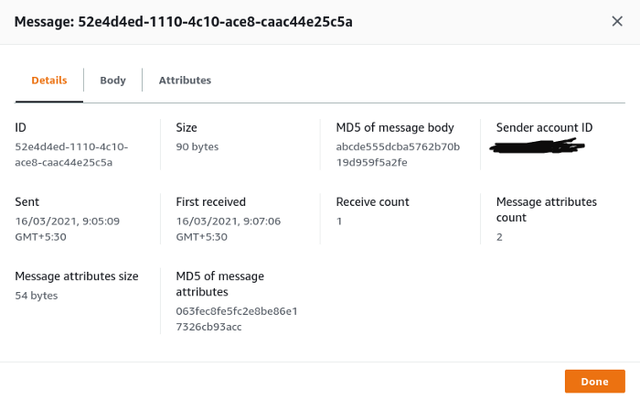
Observe the message attributes
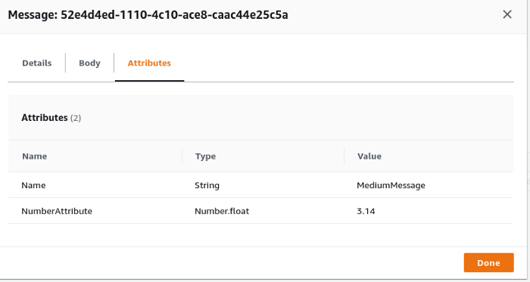
If you don’t want to test a message being published from SNS , you can skip to Step 13 else continue.

Step 11:
Quickly locate SNS to see that your SQS queue is being added as a subscriber to the SNS Queue.

You can click on the Subscription and publish a message to SQS now via SNS.
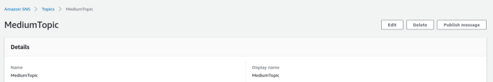
Set attributes to the message being published from SNS.
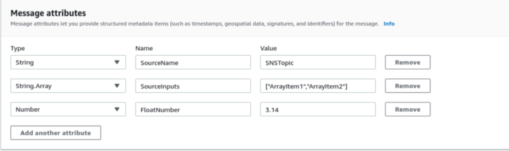

Step 12:
Verify the message published by SNS is received by the subscriber SQS
Take a look at the message
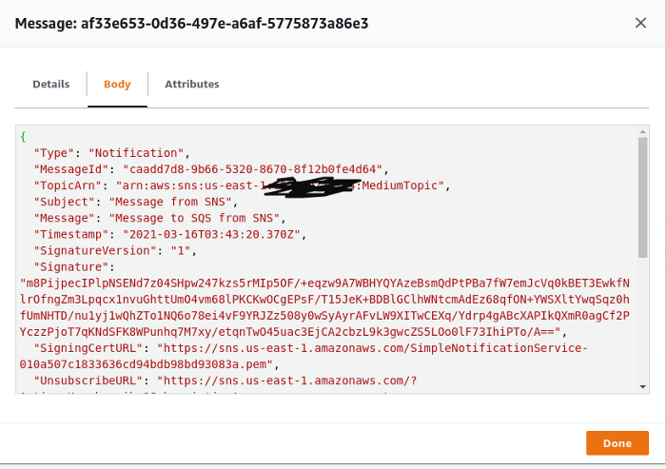
Step 13:
It’s time to test the Dead-Letter-Queue.
Since we do not have a scenario of message processing failure , let’s emulate it using the Poll Message function. When the queue is being polled ( checked for any existing messages ) messages that are still in the queue get their “Received Count” incremented.


And , by now you would have guessed where is this “Received Count” being used. Yes !! the setting “Max Receive Count” we did on Step 4.
By hitting the Poll for messages more than 10 times makes the message disappear from the queue MyStandardSQSQueue and pushes them to MyStandardSQS_DLQ . Quickly go to the DLQ and check . And there you see the message .
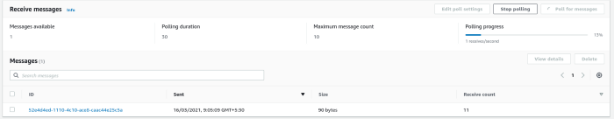
Parting thoughts:
SQS provide a robust , scalable message queuing system that can enable us to de-couple applications to off-load heavy compute processing handled without affecting the overall system performance.

